2018 Annual California, Los Angeles Public Affairs Christmas Gala
Written by Faithful Searle
Photos by Catherine Zant

Angels were heard on high at the Annual Public Affairs Christmas Gala, Thursday, November 29, 2018. The event was hosted and held at The Los Angeles Temple Visitors Center of The Church of Jesus Christ of Latter-day Saints. Guests included Consuls General, as well as Interfaith, Government, Education, Civic and Community Leaders.

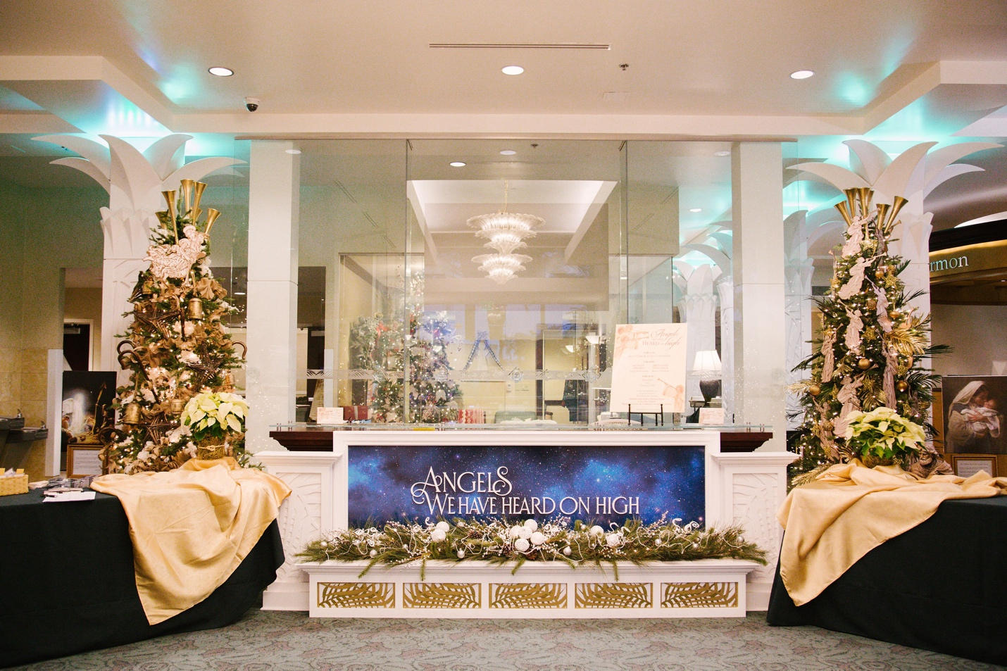
A welcoming entrance to the Visitors’ Center

The keynote speaker was Greg Mckeown, who recently published New York Times and Wall Street Journal bestseller Essentialism: The Disciplined Pursuit of Less. McKeown has addressed audiences worldwide on the importance of prioritizing our lives. He was followed by noted Broadway performer, Kevin Odekirk, presenting his newly arranged Christmas album.

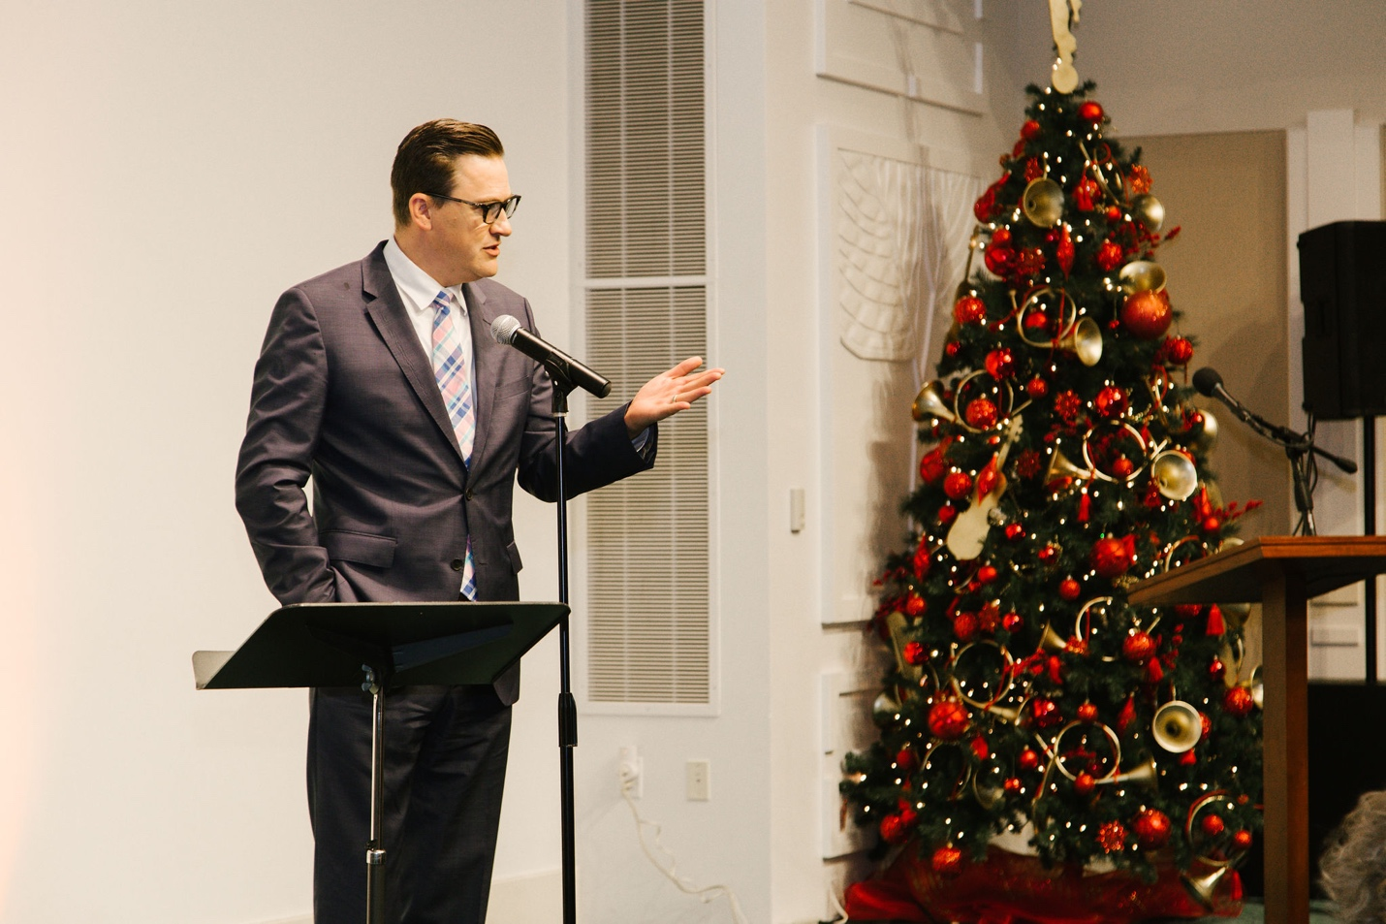
Greg Mckeown invites Gala guests to examine what matters most in their lives.

The Southern California Public Affairs Coordinating Council and the Los Angeles Public Affairs team host the Gala each year. It has become a beloved Christmas tradition for many guests. Missionaries from the California Los Angeles Mission served as volunteers to assist in various capacities during the event.

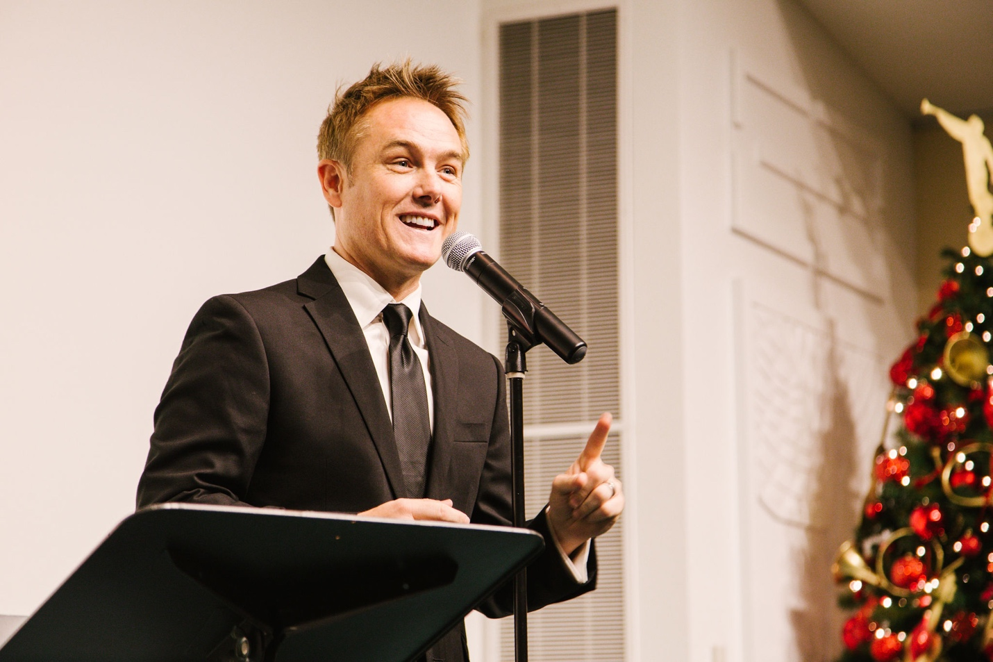
Kevin Odekirk, Broadway performer, shares what Christmas means to him.

The purpose of the Gala is to create unity. People of all nationalities and religious backgrounds join to celebrate the common principles that make Christmas special; service, spiritual strength, and prioritizing relationships.

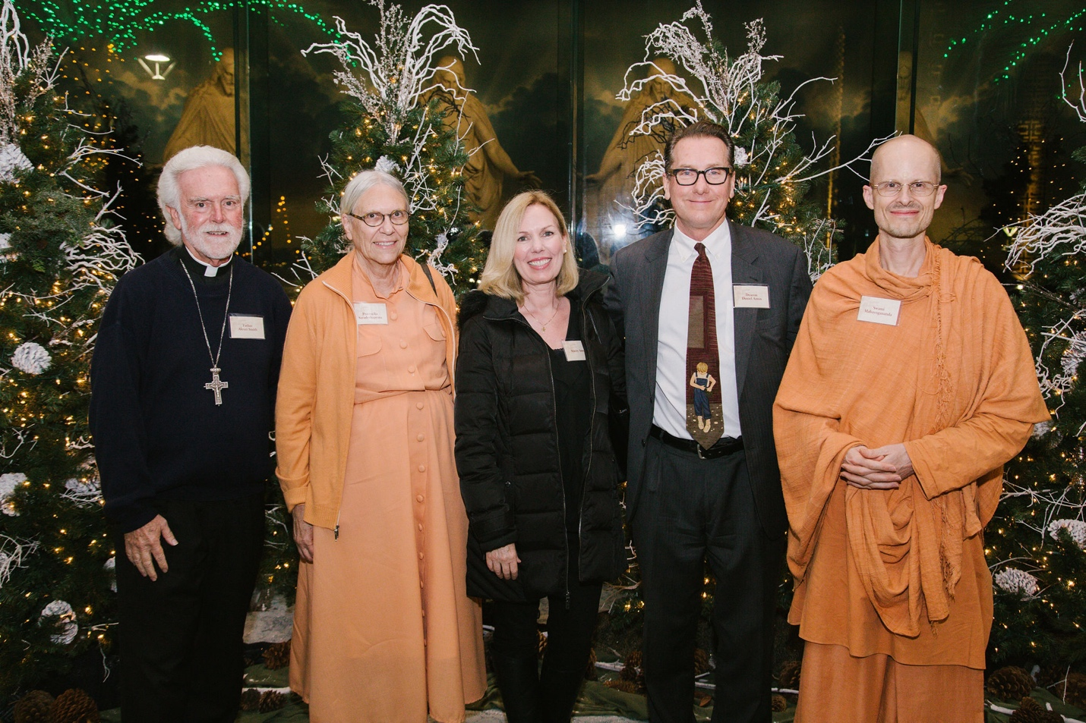
Left to right: Father Alexei Smith, Pravrajika Saradeshprana, Stacey Amos, Daniel Amos, Swami Mahayogananda

Each detail of the Gala was designed to include all backgrounds and belief systems. This included foods to meet the health codes of each religious group who would attend.

As Greg McKeown spoke, he invited each guest to draw closer to God by making choices that would help each of us to grow spirituality. The Christmas message applied to all – put God first, and things will begin to align in our lives. Speaking with Susanne and Roger Wildhaber, representatives of the Consul General of Sweden, the message was well-received. Concerning the theme of the night, they said,
“We love coming here during Christmas-time, it’s a wonderful event. Communication and respect are key for successful relationships.”

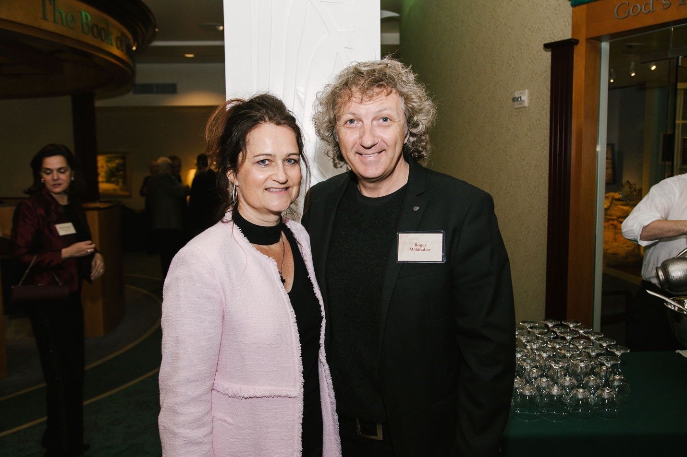
Susanne and Roger Wildhaber, representing the Consulate of Sweden.

Many guests at the Annual Gala return each year to celebrate and reconnect. Some attended for their first time this year. Two members of Los Angeles Rotary Club, Maureen and Angelo Tepedino, said, “this is our first time here at The Los Angeles Temple Visitors Center, it’s great to be here. We never knew all the things [the Church’s Public Affairs] does here, we are amazed!”

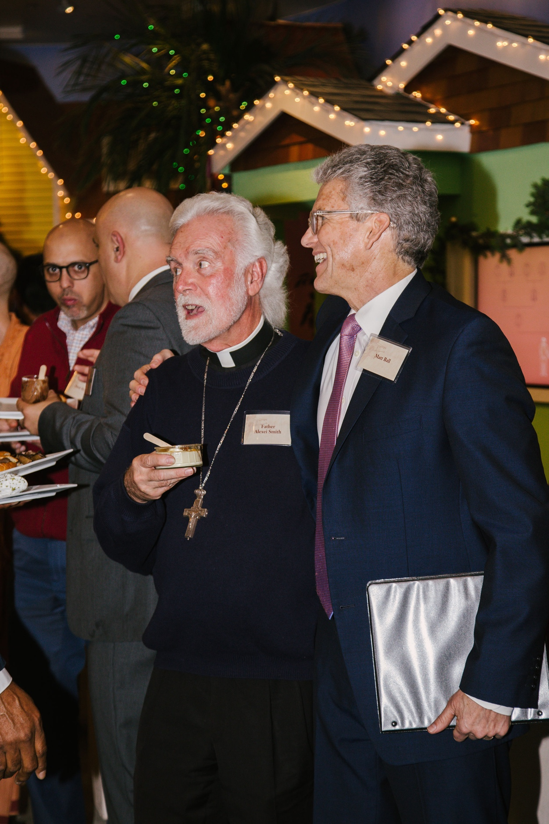
Father Alexei Smith and Southern California Public Affairs Director, Matt Ball.
The Annual Christmas Gala is an opportunity for Consuls General and other international representatives to see what The Church of Jesus Christ of Latter-day Saints can bring to their country. Serving guests at the Gala mirrors the service offered by members of the Church in countries throughout the world.

Sister Velazquez providing Greg McKeown’s book and Kevin Odekirk’s CD to Consul General of Bolivia, Marco Antonio Valverde.

Many in attendance were impacted by the comraderie at the Visitors’ Center. Community Activist and spiritual leader, Mac Shorty, was deeply touched by the love and welcoming he felt at the event.

“I’ve never come to anything like this before, it’s amazing! I have to bring my family back here to see the temple,” he said.

