Members of Thousand Oaks, CA Protect Stake Center from Wildfires

Friday, November 9th was the beginning to a weekend filled with loss among residents in Southern California. The wildfires had grown uncontrollable, destroying homes, taking lives, and wreaking devastation. Yet, amidst the chaos, members of the Church of Jesus Christ of Latter-Day Saints chose to safeguard their places of worship from the flames.
Jerry Stevens, who is serving on the Church’s Thousand Oaks High Council, received a phone call at 1:30 in the morning from a counselor in his Elder’s Quorum, Stevens was asked to check on his assigned ministering families in the mandatory evacuation zones.
They turned on the television and soon realized Thousand Oaks was now enveloped in the fire. Stevens says, “I went outside to determine what was visible. I could see the sky aglow over the hill near our house.” The flames had worked their way south. The flames headed in the direction of the Stake Center. By now, it was two o’clock in the morning and the traffic was heavy with evacuees.
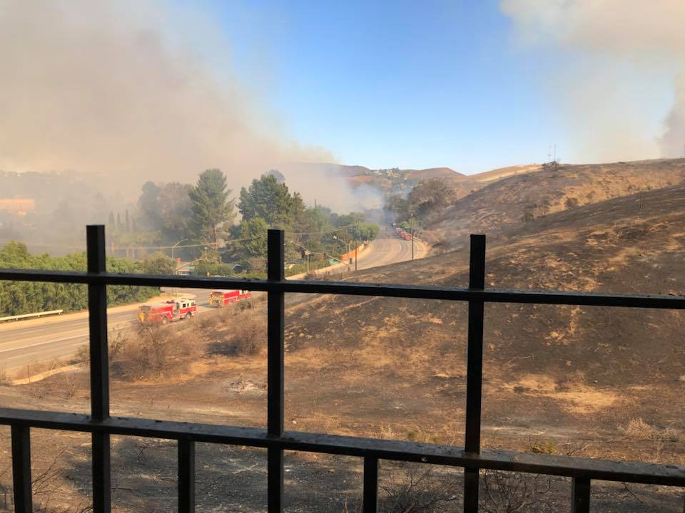
When Stevens approached the Stake Center, he saw a fireman monitoring the fire’s movement. A fire engine drove up to the street neighboring the church building and was containing fires from the housing area south of the church.
Small spot fires freckled the church’s landscaping. Dale Hendrickson, a member of the Thousand Oaks Ward, picked up a fire extinguisher and began putting out fires, one by one. Like trick birthday candles, the embers reignited repeatedly due to the heat coming from beneath the mulch. Hendrickson sent out a group text message to fellow ward members, asking them to bring buckets and hoses. Several youth and adult members from the Stake arrived.
By four in the morning, police had secured the area surrounding the church building. A fire engine arrived in the parking lot to contain the fire on the perimeter. The fire began to grow in strength around the church property. There was a severe heat around the entire area.
One of the firemen stationed to protect the stake center was Rod, Zierenburg, a member of the Church.
Members of the Church then found a garden hose in one of the church building’s storage closets. They used it to keep out the fires growing on the mulch in the parking lot. Passersby noticed the efforts being made to protect the church building and began to offer their assistance. Members and nonmembers alike began working to contain the fire and protect the sacred building. Approximately 30 members of the Church gathered and offered their help. Eventually, a water tank arrived, providing enough water to extinguish the fire completely.
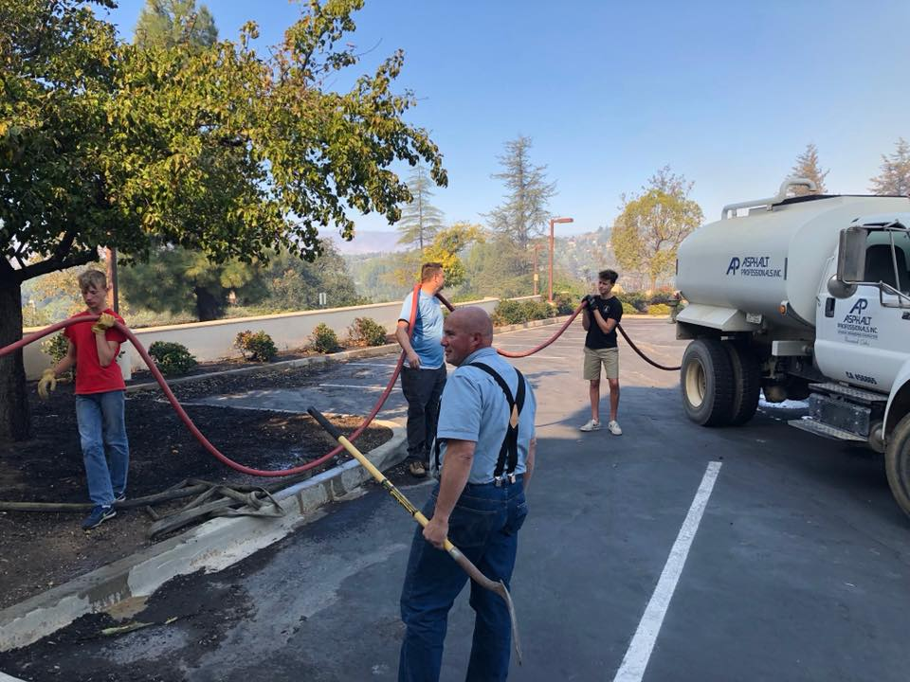
The next morning, another 45 members of the Thousand Oaks Ward arrived at the church property with shovels, rakes, brooms, and blowers. They cleaned all remaining mulch and debris from the church areas.
“The fires have overshadowed everything else that seemed important for the weekend,” Thousand Oaks Stake President, Paul Manwaring, said,
“Safety is the greatest concern.” Currently, the members of the Thousand Oaks Stake are safe, as well as their beloved Stake Center.
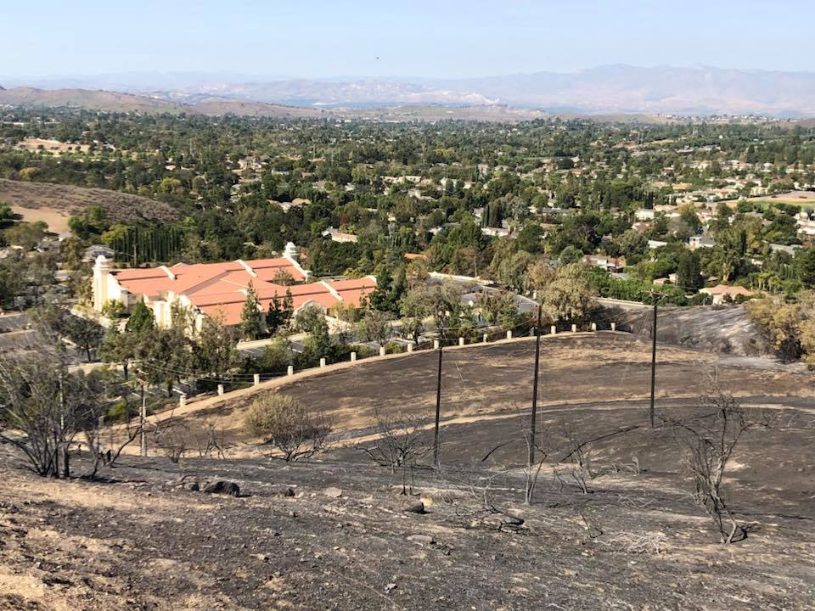
President Manwaring described the scene as one free of panic or chaos. Because the fires surrounding the Church were mainly landscaping fires, those extinguishing the flames were not in grave danger. However, without those members volunteering their services, the outcome would have been very different.
Speaking of members of the Church working through the morning to protect their stake center, the firemen said, “They are the heroes!”

