Biker Gangs, Missionaries, and State Senator Unite to Fight Hunger This Thanksgiving

“It’s a beautiful day to come get a turkey,” said Bruce, a resident of Hawthorne, California. Bruce is one of many gathered in his neighborhood, grateful to receive a Thanksgiving turkey.

Senator Steven Bradford coordinated the annual “Operation Gobble” on November 19, 2018 at Rowley Park, joined by Assemblywoman, Autumn Burke of the 62nd District. Numerous volunteers gathered from all corners to assist the grateful crowd of receiving families and individuals.

The first of all the volunteers to arrive were the biker gangs of Hawthorne. The group has worked together for years, spending multiple days a week volunteering at local events.

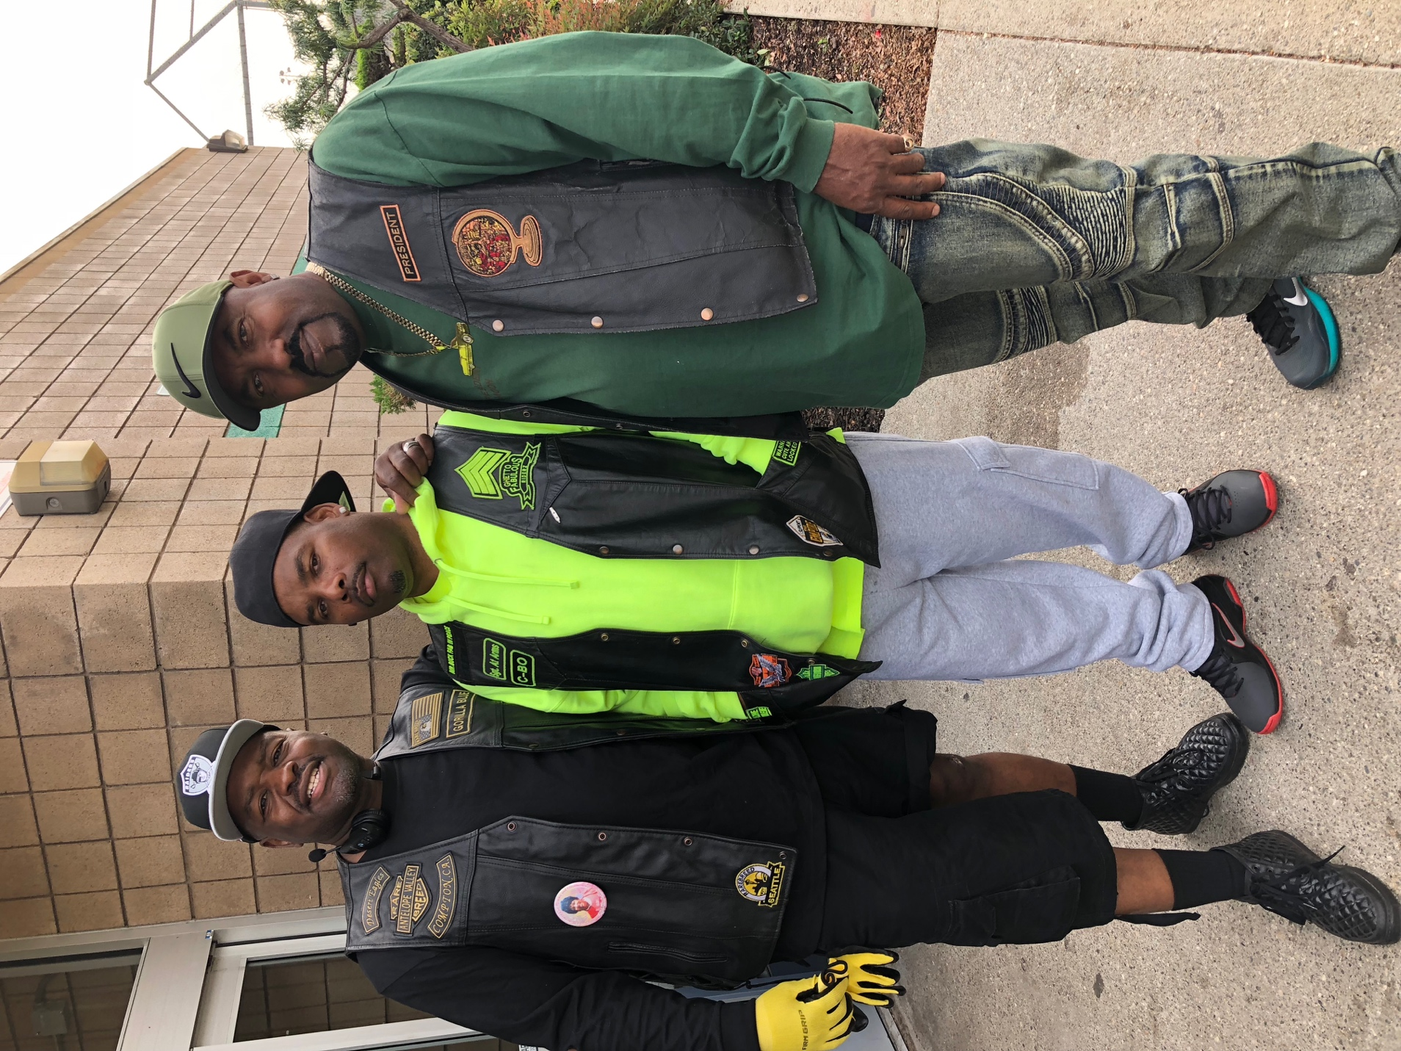

President Moon, leader of the biker gang, “Ghetto Life,” said, “We just really like coming out here and helping.” His friends were instrumental in the success of the event. They unloaded the 500 hundred turkeys donated by the Church of Jesus Christ of Latter-Day Saints.

Many of the members of the biker gangs have tender feelings for the families in need. The service they offer comes from a place of concern and giving. Roland P. Hodge Jr. has seen the difference service has made in his life.

“I like doing this type of stuff. There are a lot of families in need. It’s from the heart. Saving a few dollars on that turkey can go a long way for a family,” said Hodge,

“I grew up in Compton myself. I did 11 calendars in prison. People think they can’t change their lives. But now, I look back over my life and can say I have been truly blessed. I have been changed.”

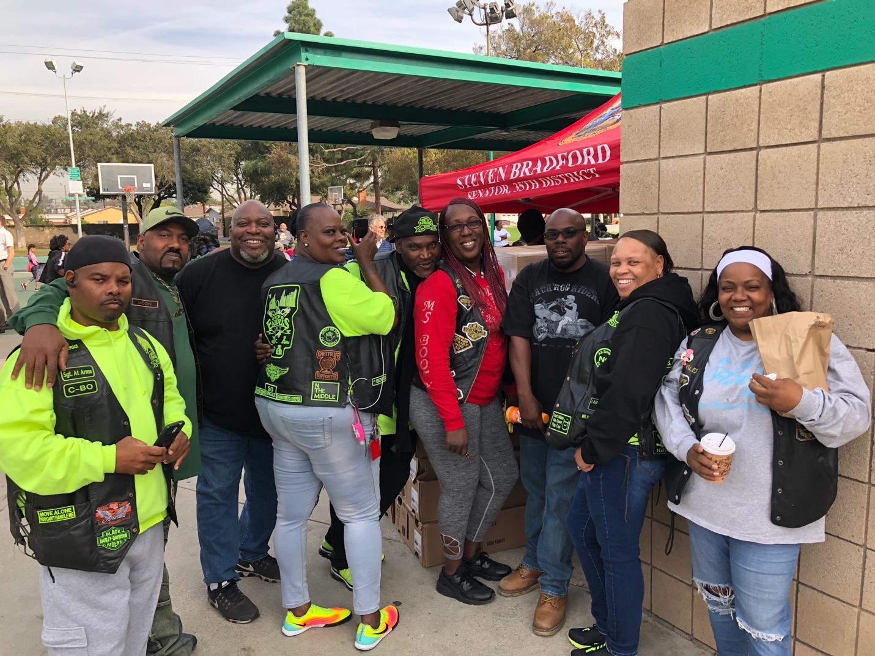

The families in need lined up to receive their Thanksgiving turkey. Turkeys were also distributed to various local congregations so that churches could give them to families who wouldn’t otherwise have a Thanksgiving meal.

A total of 1,250 turkeys and 300 hams were distributed to families in need throughout the greater Los Angeles area.

“This is a blessing to our family. We are so grateful,” said Maria. She recently moved from El Salvador to help her family here in California.

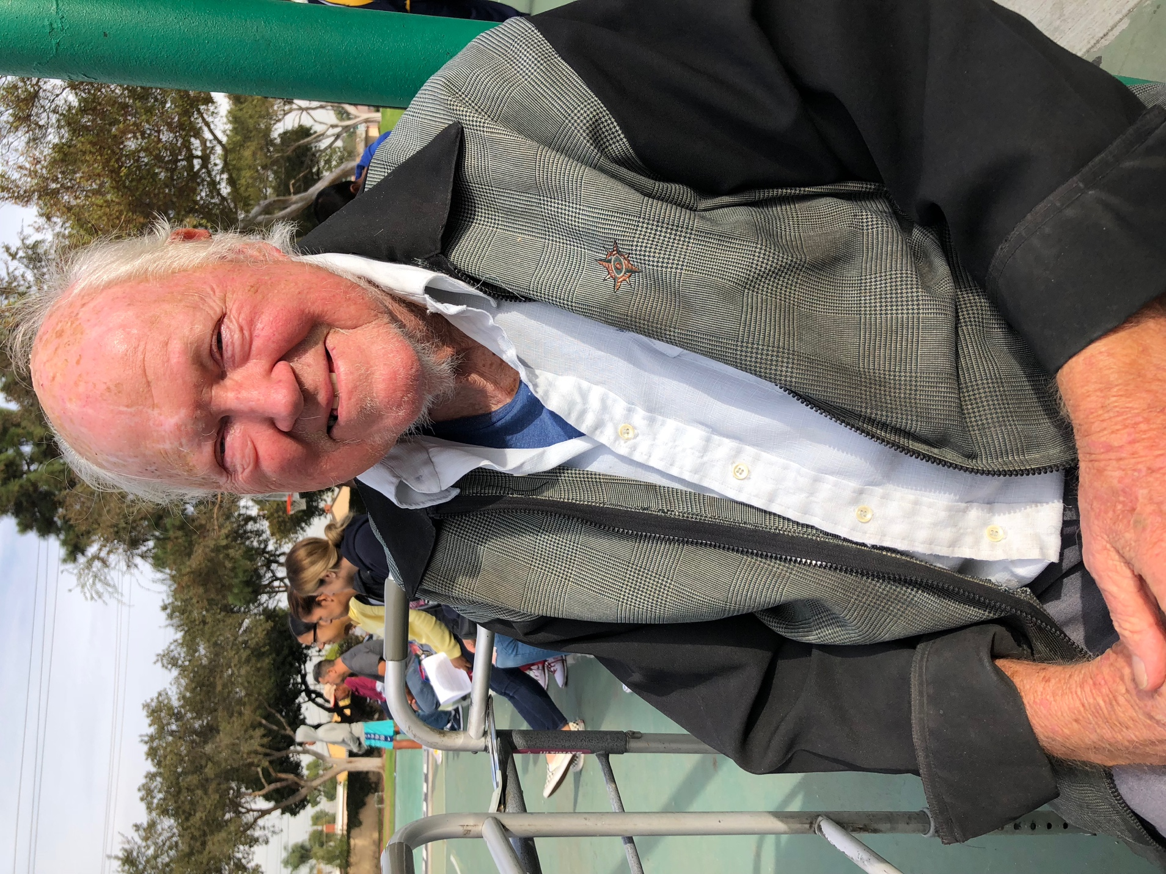

Richard, who also lives in Hawthorne, said, “Being here alone for the holidays is hard, my family all lives far. But I’m glad to have this help. Now I can have a Thanksgiving meal.”

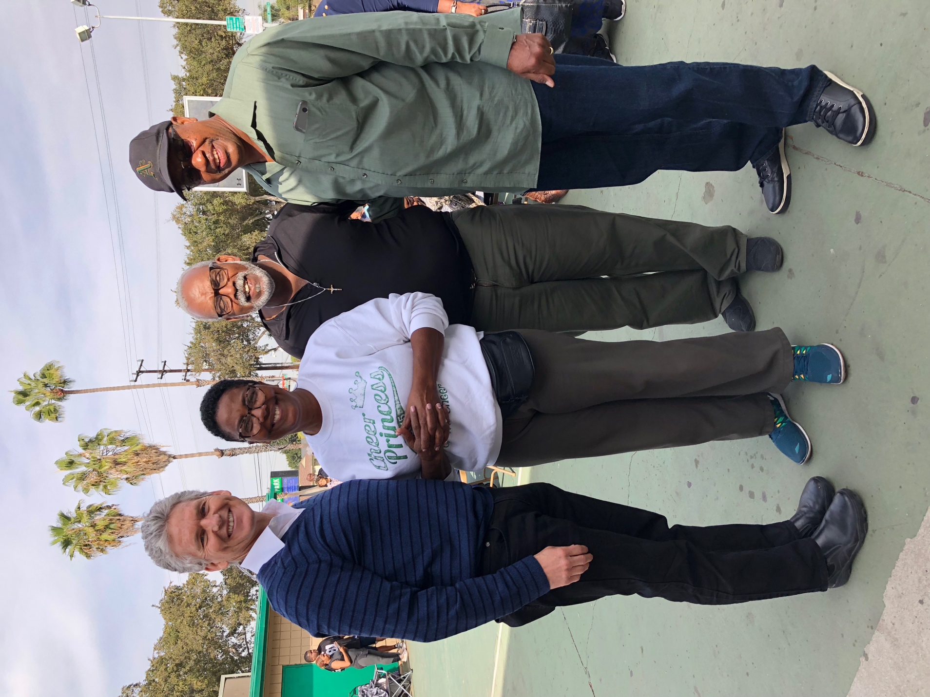

Gratitude and service filled the park, aptly fitting the season that brought everyone together. Representatives from the Church’s Public Affairs were instrumental in the event’s success. Director Matthew Ball and representatives Dean and Lynette Allen.

As he watched the missionaries offering service, Pastor Mac Shorty recalled his own positive experiences with service offered by members of Christ’s church, “The members [of the Church of Jesus Christ of Latter-Day Saints] visited me every day when I was recovering from surgery. They were the ones who got me through it all.”

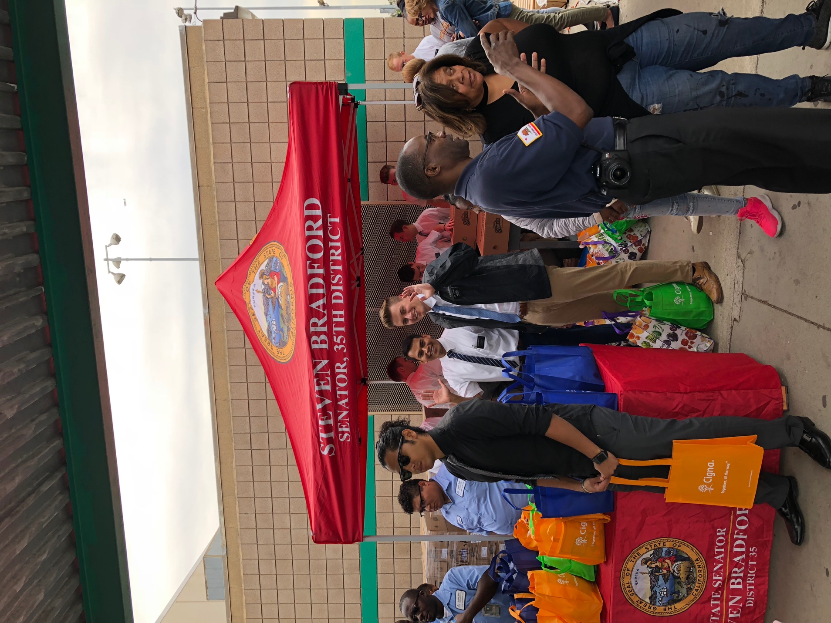

Speaking of the volunteers and donations from the Church, Darryl from Senator Bradford’s office admitted, “The Church of Jesus Christ of Latter-Day Saints is the only thing we can count on every year.”

The families gathered in the park came from various countries and walks of life. Yet, there was one common feeling in the hearts of each person at Rowley Park: the joy of giving.

